the LAC
Seussical Kids ~ Cast List
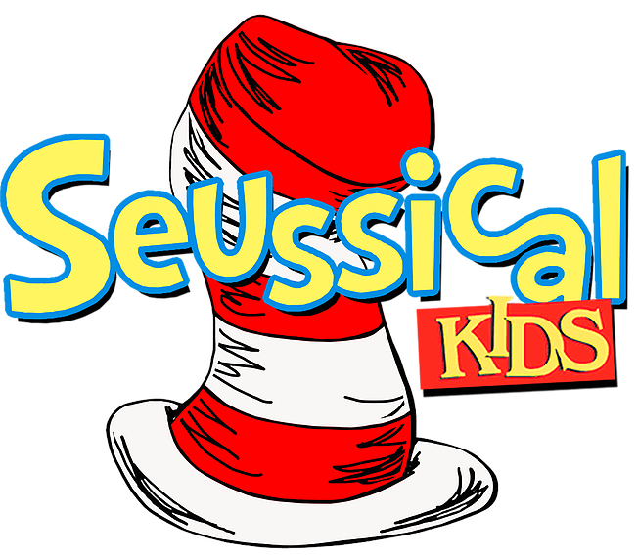

Cat One ~ Hallie Henson

Cat Two ~ Makayla Jameson

Cat Three ~ Allyson French

Jojo ~ Emma Stickl

Horton The Elephant ~ Charles Bender

Gertrude Mcfuzz ~ Ella Kate Freeman

Mayzie La Bird ~ Angie Finch

Sour Kangaroo ~ Indie Irwin

Young Kangaroo ~ Rylan Martin

Mr. Mayor ~ Jakob Samuels

Mrs. Mayor ~ Andie Pearson

Thing One/Who ~ Gianna Vyas

Thing Two/Who ~ Sara Cressman

Yertle The Turtle/Who ~ Andrew Neal

Vlad Vladikoff/Wickersham ~ Gracie Nite

Jungle Creatures ~ EVERYONE

Bird Girl One ~ Avery Graham

Bird Girl Two ~ Lily Andrus

Bird Girl Three ~ Julia Peters

Bird Girl Four ~ Charlotte Baker

Bird Girl Five ~ Lola Kirby

Bird Girl Six ~ Emma Kirby

Wickersham One ~ Presley Taliaferro

Wickersham Two ~ Lexie Matsakis

Wickersham Three ~ Zachary Gooding

The Wickersham Brothers ~ Eviana Butcher, Lane Jones, Molly McGlade, Vincent Penner, Addison Randolph, Parker Schimmelman, Levi Whitley, Abby Papit, Lane Jones

The Whos ~ Sara Buta, Emma Deering, Jenna Dickson, Ainsley Haley, Jemma Hawkins, Victory Keeler, Lorelei Le, Adrian Razavi

It’s Possible Dancers ~ Jemma Hawkins, Victory Keeler, Charis Osborne, Addison Randolph

Alone in the Universe Dancers ~ Jenna Dickson, Gracie Nite, Presley Taliaferro, Lexie Matsakis,

